Lecture 3.3.5
Spanning Tree and Minimum Spanning Tree
Course outcome to be covered:
CO4: Apply and recognized about the Trees

Topic Objectives:
By the end of this module, the learner will be able to:
1. Analyze the solution of the minimum spanning tree problem.
2. Study a generalized approach to obtaining an algorithm to solve the Minimum Spanning tree problem.
3. Identify some problems that fit this algorithm.

1. Introduction:
One of the advantages of trees is that they give us a few simple ways to travel through the vertices. If a connected graph is not a tree, then we can still use these traversal algorithms if we identify a sub-graph that is a tree.
First we should consider if this even makes sense. Given any connected graph G, will there always be a sub-graph that is a tree? Well, that is actually too easy: you could just take a single edge of G.G. If we want to use this sub-graph to tell us how to visit all vertices, then we want our sub-graph to include all of the vertices. We call such a tree a spanning tree. It turns out that every connected graph has one (and usually many).

2. Motivation

The topic of spanning trees is motivated by a graph-optimization problem.
A graph of Atlantis University (Figure 1) shows that there are four campuses in the system. A new secure communications system is being installed and the objective is to allow for communication between any two campuses; to achieve this objective, the university must buy direct lines between certain pairs of campuses. Let G be the graph with a vertex for each campus and an edge for each direct line. Total communication is equivalent to G being a connected graph. This is due to the fact that two campuses can communicate over any number of lines. To minimize costs, the university wants to buy a minimum number of lines.

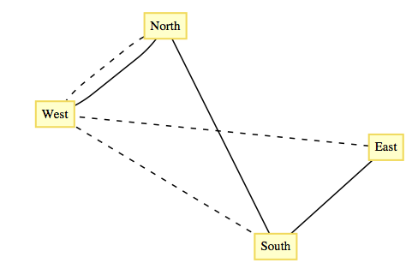
Figure 1. Atlantis University Graph

The solutions to this problem are all trees. Any graph that satisfies the requirements of the university must be connected, and if a cycle does exist, any line in the cycle can be deleted, reducing the cost. Each of the sixteen trees that can be drawn to connect the vertices North, South, East, and West solves the problem as it is stated. Note that in each case, three direct lines must be purchased. There are two considerations that can help reduce the number of solutions that would be considered.
- Objective 1: Given that the cost of each line depends on certain factors, such as the distance between the campuses, select a tree whose cost is as low as possible.
- Objective 2: Suppose that communication over multiple lines is noisier as the number of lines increases. Select a tree with the property that the maximum number of lines that any pair of campuses must use to communicate with is as small as possible.

Typically, these objectives are not compatible; that is, you cannot always simultaneously achieve these objectives. In the case of the Atlantis university system, the solution with respect to Objective 1 is indicated with solid lines in Figure1. There are four solutions to the problem with respect to Objective 2: any tree in which one campus is directly connected to the other three. One solution with respect to Objective 2 is indicated with dotted lines in Figure1. After satisfying the conditions of Objective 2, it would seem reasonable to select the cheapest of the four trees.

3. Spanning Tree
A spanning tree is a subset of Graph G, which has all the vertices covered with minimum possible number of edges. Hence, a spanning tree does not have cycles and it cannot be disconnected..
By this definition, we can draw a conclusion that every connected and undirected Graph G has at least one spanning tree. A disconnected graph does not have any spanning tree, as it cannot be spanned to all its vertices.
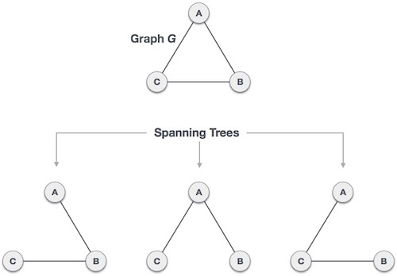
Figure2. Spanning Tree

We found three spanning trees off one complete graph. A complete undirected graph can have maximum n^{n-2} number of spanning trees, where n is the number of nodes. In the above addressed example, n is 3, hence 3³⁻² = 3 spanning trees are possible.

3.1 Definition

Let G=(V,E) be a connected undirected graph. A spanning tree for G is a spanning sub-graph of G that is a tree.

3.1.1 Note

If (V,E′) is a spanning tree, |E′|=|V|−1.
The significance of a spanning tree is that it is a minimal spanning set. A smaller set would not span the graph, while a larger set would have a cycle, which has an edge that is superfluous.

3.2 General Properties of Spanning Tree
We now understand that one graph can have more than one spanning tree. Following are a few properties of the spanning tree connected to graph G −
- A connected graph G can have more than one spanning tree.
- All possible spanning trees of graph G, have the same number of edges and vertices.
- The spanning tree does not have any cycle (loops).
- Removing one edge from the spanning tree will make the graph disconnected, i.e. the spanning tree is minimally connected.
- Adding one edge to the spanning tree will create a circuit or loop, i.e. the spanning tree is maximally acyclic.

3.3 Mathematical Properties of Spanning Tree
- Spanning tree has n-1 edges, where n is the number of nodes (vertices).
- From a complete graph, by removing maximum e - n + 1 edges, we can construct a spanning tree.
- A complete graph can have maximum n^{n-2} number of spanning trees.
Thus, we can conclude that spanning trees are a subset of connected Graph G and disconnected graphs do not have spanning tree.

3.4 Application of Spanning Tree
Spanning tree is basically used to find a minimum path to connect all nodes in a graph. Common application of spanning trees are −
- Civil Network Planning
- Computer Network Routing Protocol
- Cluster Analysis
Let us understand this through a small example. Consider, city network as a huge graph and now plans to deploy telephone lines in such a way that in minimum lines we can connect to all city nodes. This is where the spanning tree comes into picture.

3.5 Example of Spanning Tree
Let us understand spanning tree with example below
Let the original graph be
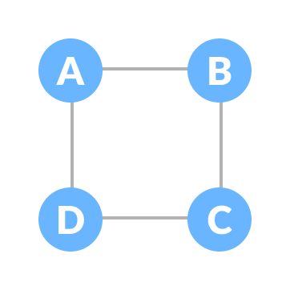
Figure3. Normal Graph
Some of the possible spanning trees that can be formed from the above graph are
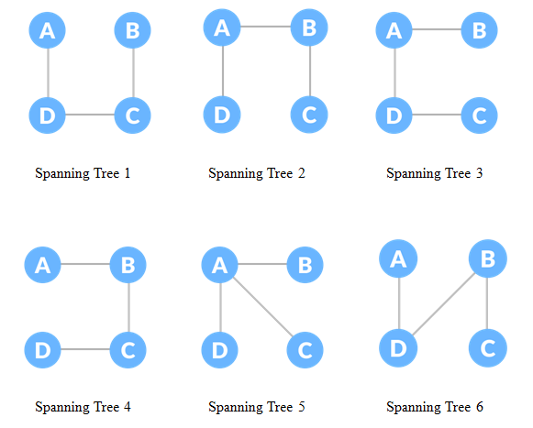

Figure4. Some examples of possible spanning tree from Figure 3

4. Minimum Spanning Tree (MST)
In a weighted graph, a minimum spanning tree is a spanning tree that has minimum weight than all other spanning trees of the same graph. In real-world situations, this weight can be measured as distance, congestion, traffic load or any arbitrary value denoted to the edges.

4.1 Definition Minimal Spanning Tree.
Given a weighted connected undirected graph G=(V,E,w), a minimal spanning tree is a spanning tree (V,E ′) for which ∑e∈E′w(e) is as small as possible.

4.2 Applications of Minimum Spanning Tree
- To find path in the map
- To design networks like telecommunication network, water supply network and electrical grids.

4.3 Minimum Spanning-Tree Algorithm
We shall learn about two most important spanning tree algorithms here −
- Kruskal's Algorithm
- Prim's Algorithm
Both are greedy algorithms.

5. Difference between Spanning Tree and Minimum Spanning Tree

Well spanning tree is a path in graph which contains all the nodes without forming a cycle. Minimum spanning tree is a concept in weighted graphs where path formulated has minimum sum of edge weights over all possible paths. The following figure basically shows their difference
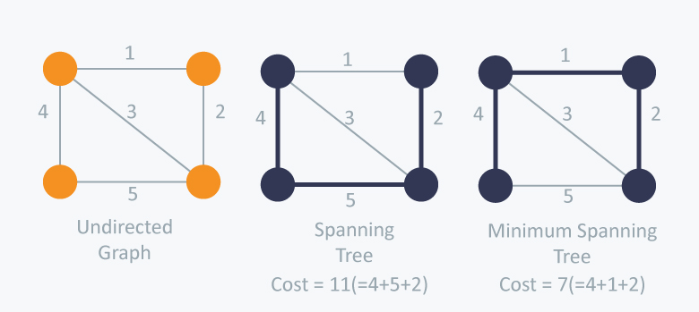Figure5. Difference between Spanning Tree and Minimum Spanning Tree

Summary
In this lecture we studied about the following topics in deep:
- Introduction One of the advantages of trees is that they give us a few simple ways to travel through the vertices
- Motivation The topic of spanning trees is motivated by a graph-optimization problem.
- Spanning Tree A spanning tree is a subset of Graph G, which has all the vertices covered with minimum possible number of edges
- Contents Definition, General properties, Mathematical Properties, Applications and Examples of Spanning Tree
- Minimum Spanning Tree A minimum spanning tree is a spanning tree that has minimum weight than all other spanning trees of the same graph
- Difference between Spanning and Minimum Spanning Tree
Applications in the Field of Computer Science Engineering
Minimum spanning trees are used for network designs (i.e. telephone or cable networks). They are also used to find approximate solutions for complex mathematical problems like the Traveling Salesman Problem. Other, diverse applications include:
  - Cluster Analysis.
  - Real-time face tracking and verification (i.e. locating human faces in a video stream).
  - Protocols in computer science to avoid network cycles.
  - Entropy based image registration.
  - Max bottleneck paths.
  - Dithering (adding white noise to a digital recording in order to reduce distortion).

FAQs
  - How many edges does minimum spanning tree has ?
The graph contains 9 vertices and 14 edges. So, the minimum spanning tree formed will be having (9 – 1) = 8 edges. 1.
  - How do you calculate spanning tree?
Total number of Spanning Trees in a Graph. If a graph is a complete graph with n vertices, then total number of spanning trees is n^{(n-2)} where n is the number of nodes in the graph. In complete graph, the task is equal to counting different labeled trees with n nodes for which have Cayley's formula.
  - How many spanning trees are possible in graph?
Spanning tree has n-1 edges, where n is the number of nodes (vertices). From a complete graph, by removing maximum e - n + 1 edges, we can construct a spanning tree. A complete graph can have maximum n^{n-2} number of spanning trees.

Getting Started
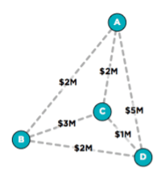How much do you think the Internet costs to build and maintain?
Present this diagram on the board or projector.
Let’s say that you are in charge of not one router, but several, and your job is to connect them so that a) any packet can get from any router to any other router in your system, and b) you want to build these connections as cheaply as possible.
Say you are in charge of 4 routers placed at various locations in a region. The diagram shows the possible connections that could be made between any pair of routers and the associated cost of building a connection between them (in millions of dollars).
Question: Which connections would you choose to build to keep the total cost down?
Let students work it out in pairs or individually and share solutions. (See Key: Lesson Plan Activities for solutions.)
Question: Can you come up with a clear strategy, or process, for finding the minimal-cost connections you need, not only for this network, but any network, especially if the network were bigger?
Why do we care about coming up with a strategy or process for solving this problem, rather than just finding an answer?

